# **Predicting student's performance in the test "Saber PRO"**

|  |  |  |  |
| --- | --- | --- | --- |
| Julian Gomez Benitez  University Eafit  Colombia  jgomezb11@eafit.edu.co | Juan Pablo Rincon Usma  University Eafit  Colombia  jprinconu@eafit.edu.co | Miguel Correa Universidad Eafit Colombia macorream@eafit.edu.co | Mauricio Toro  Universidad Eafit  Colombia  mtorobe@eafit.edu.co |

**Red text =** Comments

**Black text =** Miguel and Mauricio’s contribution

**Green text** = To complete for the 1st deliverable

**Blue text**  = To complete for the 2nd deliverable

**Violet text** = To complete for the 3rd deliverable

# **ABSTRACT**

Today technology gives us a proportion of data that we can use to predict results about everyday things that happen around us, we want to focus on predicting academic success through academic and sociodemographic variables, the idea is to analyze these data and predict whether students will be able to do well on the "Saber pro" tests. Similar studies have been carried out which allow us to determine how the students will do, and they have given good results, taking this into account, help can be offered to students who have difficulties and thus avoid that their grades decrease considerably. Which is the algorithm you proposed?, What results did you achieve? , What are the conclusions of this work? Abstract should have **at most 200 words**. (*In this semester, you should summarize here execution times, memory consumption, accurracy, precision and sensibility*)

## **Keywords**

|  |
| --- |
| Decision trees, machine learning, academic success,  standardized student scores, test-score prediction |

# **1. INTRODUCTION**

# in a future, the technology is going to be the new key for the education using the digital transformation process of education in Colombia.

# In the past has been studied the causes and motivations that influence of academic desertion, using algorithm to predict the academic desertion, even so, few have managed to predict the academic success in the higher education, the academic success can be consider like the employability of the graduate, the salary of the graduate or even the happiness in their jobs.

# For this project we will consider the academic success like the probability of that one student gets a score above average of another students. The test "Saber Pro" are the Colombian´s government test that is design for the university students, that are about to finish the college.

# **1.1. Problem**

We want to design an algorithm base on decision tree and the information of "Saber 11" to predict the if a student will get a score above average. For this we have the dates of his age, his degree, his parent's salary, his gender, his stratum, etc.

**1.2 Solution**

In this work, we focused on decision trees because they provide great explainability (*A* c*itation for this argument is missing!*). We avoid black-box methods such as neural networks, support-vector machines and random forests because they lack explainability. (*Another* c*itation for this argument is missing!*)

Explain, briefly, your solution to the problem *(In this semester, the solution is an implementation of a decision-tree algorithm to predict academic success. Which algorithm did you choose? Why?)*

**1.3 Article structure**

In what follows, in Section 2, we present related work to the problem. Later, in Section 3 we present the datasets and methods used in this research. In Section 4, we present the algorithm design. After, in Section 5, we present the results. Finally, in Section 6, we discuss the results and we propose some future work directions.

**2. RELATED WORK**

## Explain four (4) articles related to the problem described in Section 1.1. You may find the related problems in scientific journals. Consider Google Scholar for your search. *(In this semester, related work is research on decision trees to predict student-test scores or academic success)*

## **3.1 PREDICTING STUDENTS’ PERFORMANCE USING ID3 AND C4.5 CLASSIFICATION ALGORITHMS**

An educational institution needs to have an approximate prior knowledge of enrolled students to predict their performance in future academics. This helps them to identify promising students and also provides them an opportunity to pay attention to and improve those who would probably get lower grades.

we have developed a system which can predict the performance of students from their previous performances using concepts of data mining techniques under Classification. We have analyzed the data set containing information about students, such as gender, marks scored in the board examinations of classes X and XII. By applying the ID3 (Iterative Dichotomiser 3) and C4.5 classification algorithms on this data. for a total of 182 students, the average percentage of accuracy achieved in Bulk and Singular Evaluations is approximately 75.275.

PREDICTING STUDENTS’ PERFORMANCE USING ID3 AND C4.5 CLASSIFICATION ALGORITHMS (N.o 5).(2013). https://arxiv.org/ftp/arxiv/papers/1310/1310.2071.pdf

## **3.2** **Mining Student Data Using Decision Trees**

Student performance in university courses is of great concern to the higher education managements where several factors may affect the performance. We use the data mining processes, particularly classification, to help in enhancing the quality of the higher educational system by evaluating student data. From the obtained results, we can notice that the classification accuracy algorithms are not so high. This can indicate that the collected samples and attributes are not sufficient to generate a classification model of high quality.

Mining Student Data Using Decision Trees. (2006). https://www.acit2k.org/ACIT2006/Proceeding/131.pdf

## **3.3 Predicting Student Performance using Classification and Regression Trees Algorithm.**

Student academic achievement is always a matter of great concern to education stakeholders, especially in today’s fastpaced, web-enabled classrooms. High quality teaching stuff, well-designed curriculum, student-centered learning and academic support are heavily impact on student success and help to equalize education background differences. Classification and Regression Trees (CART) decision tree algorithm was used to classify students and predict those at risk, based on the impact of four online activities: message exchanging, group wiki content creation, course files opening and online quiz taking. In this study, the CART technique achieved very high accuracy (99.1 %) in classifying students into those who successfully passed the class and those who failed to do so.

Predicting Student Performance using Classification and Regression Trees Algorithm .(2020). http://www.ijitee.org/wpcontent/uploads/papers/v9i3/C8964019320.pdf

**3.4** **Decision trees for predicting the academic success of students**

The aim of this paper is to create a model that successfully classifies students into one of two categories, depending on their success at the end of their first academic year, and finding meaningful variables affecting their success. The most significant variables were total points in the state exam, points from high school and points in the Croatian language exam. The highest classification rate of 79% was produced using the REPTree decision tree algorithm, but the tree was not as successful in classifying both classes. Therefore, the average rate of classification was calculated for two models that gave the highest total rate of classification, where a higher percentage is achieved using the model relying on the algorithm J48.

Decision trees for predicting the academic success of students. (2016). http://bib.irb.hr/datoteka/853222.c**lanak.pdf**

## **3. MATERIALS AND METHODS**

In this section, we explain how the data was collected and processed and, after, different solution alternatives considered to choose a decision-tree algorithm.

## **3.1 Data Collection and Processing**

We collected data from the *Colombian Institute for the Promotion of Higher Education* (ICFES), which is available online at ftp.icfes.gov.co. Such data includes anonymized Saber 11 and Saber Pro results. Saber 11 scores of all Colombian high schools graduated from 2008 to 2014 and Saber Pro scores of all Colombian bachelor-degree graduates from 2012 to 2018 were obtained. There were 864,000 records for Saber 11 and records 430,000 for Saber Pro. Both Saber 11 and Saber Pro, included, not only the scores but also socio-economic data from the students, gathered by ICFES,  before the test.

In the next step, both datasets were merged using the unique identifier assigned to each student. Therefore, a new dataset that included students that made both standardized tests was created. The size of this new dataset is 212,010 students. After, the binary predictor variable was defined as follows: Does the student score in Saber Pro is higher than the national average of the period?

It was found out that the datasets were not balanced. There were 95,741 students above average and 101,332 students below average. We performed undersampling to balance the dataset to a 50%-50% ratio. After undersampling, the final dataset had 191,412 students.

Finally, to analyze the efficiency and learning rates of our implementation, we randomly created subsets of the main dataset, as shown in Table 1. The dataset was divided into 70% for training and 30% for testing. Datasets are available at [https://github.com/mauriciotoro/ST0245-Eafit/tree/master/proyecto/dataset](https://github.com/mauriciotoro/ST0245-Eafit/tree/master/proyecto/datasets)s .

|  |  |  |  |  |  |
| --- | --- | --- | --- | --- | --- |
|  | **Dataset 1** | **Dataset 2** | **Dataset 3** | **Dataset 4** | **Dataset 5** |
| **Train** | 15,000 | 45,000 | 75,000 | 105,000 | 135,000 |
| **Test** | 5,000 | 15,000 | 25,000 | 35,000 | 45,000 |

## **Table 1.** Number of students in each dataset used for training and testing.

## **3.2 Decision-tree algorithm alternatives**

## In what follows, we present different algorithms to solve to automatically build a binary decision tree. *(In this semester, examples of such algorithms are ID3, C4.5,* *Hierarchical clustering,* *Decision tree learning).*

**3.2.1** **Hierarchical clustering**

hierarchical clustering is a method of cluster analysis which seeks to build a hierarchy of clusters. Strategies for hierarchical clustering generally fall into two types:

Agglomerative: This is a "bottom-up" approach: each observation starts in its own cluster, and pairs of clusters are merged as one moves up the hierarchy.

Divisive: This is a "top-down" approach: all observations start in one cluster, and splits are performed recursively as one moves down the hierarchy.

This algorithm has a time complexity of O($n^{3}$) and requires O($n^{2}$) memory

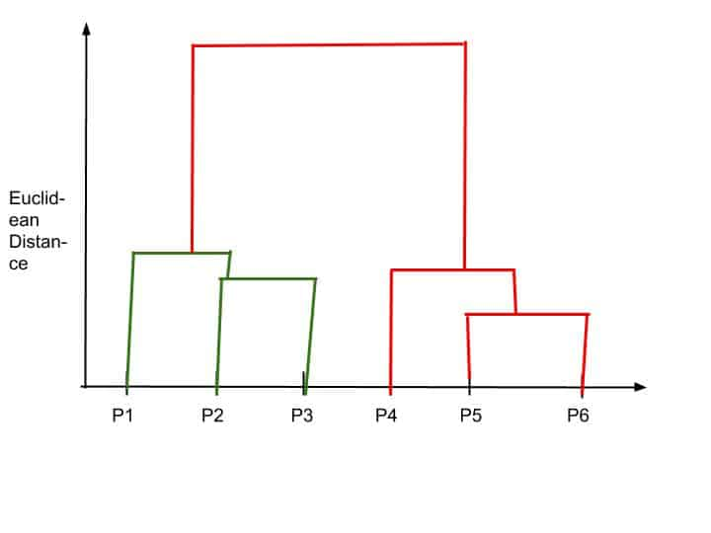**3.2.** **ID3** **algorithm**

The ID3 algorithm begins with the original set S as the root node. On each iteration of the algorithm, it iterates through every unused attribute of the set S and calculates the entropy or the information gain IG(S) of that attribute. It then selects the attribute which has the smallest entropy (or largest information gain) value. The set S is then split or partitioned by the selected attribute to produce subsets of the data. The algorithm continues to recurse on each subset, considering only attributes never selected before.

This algorithm has a time complexity of O(m · n), where m is the size of the training data and n is the number of attributes.

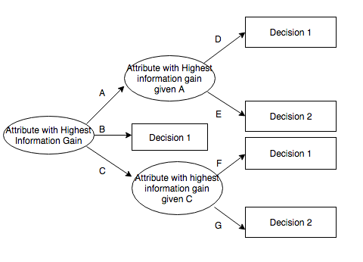

**3.2.3 C4.5 algorithm**

C4.5 builds decision trees from a set of training data in the same way as ID3, using the concept of information entropy. At each node of the tree, C4.5 chooses the attribute of the data that most effectively splits its set of samples into subsets enriched in one class or the other. The splitting criterion is the normalized information gain (difference in entropy). The attribute with the highest normalized information gain is chosen to make the decision. The time complexity O(m · n2) Where m is the size of the training data and n is the number of attributes

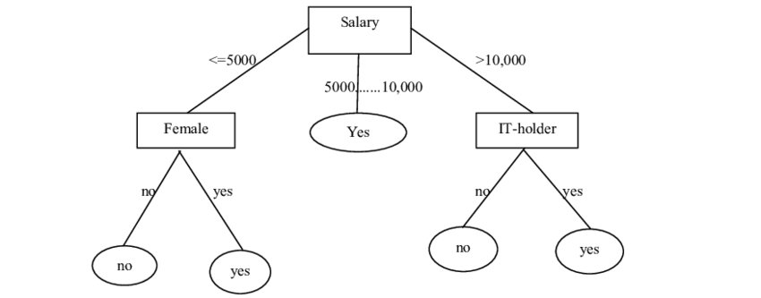

**3.2.4** **Decision tree learning**

## Decision tree learning is a method commonly used in data mining. The goal is to create a model that predicts the value of a target variable based on several input variables. A tree is built by splitting the source set, constituting the root node of the tree, into subsets—which constitute the successor children. The splitting is based on a set of splitting rules based on classification features. This process is repeated on each derived subset in a recursive manner called recursive partitioning. The standard decision-tree learning algorithm has a time complexity of O(m · n2).

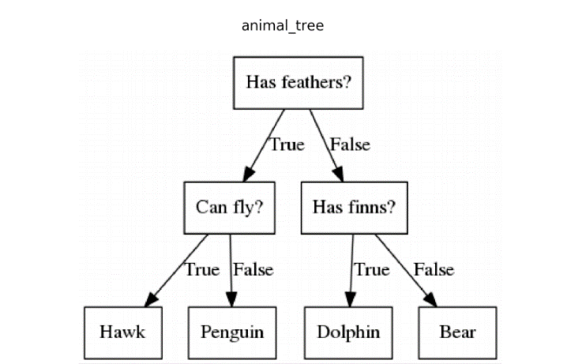

## .**4. ALGORITHM DESIGN AND IMPLEMENTATION**

## In what follows, we explain the data structure and the algorithms used in this work. The implementation of the data structure and algorithm is available at Github[1].

## **4.1 Data Structure**

## Explain the data structure used to make the prediction and make a figure explaining it. Do not use figures from the Internet. *(In this semester, the data structure is a binary decision tree)*

**Figure 1:** A binary decision tree to predict Saber Pro based on the results of Saber 11. Violet nodes represent those with a high probability of success, green medium probability and red a low probability of success.

**4.2 Algorithms**

Explain the design of the algorithm to solve the problem and make a figure. Do not use figures from the Internet, make your own. *(In this semester, one algorithm must be an algorithm to train a decision-tree algorithm such as ID3, C4.5, CART and the second algorithm must be an algorithm to classify new data using such a tree).*

**4.2.1 Training the model**

Explain, briefly, how did you train the model: This is equivalent to explain how does your algorithm build automatically a binary decision tree.

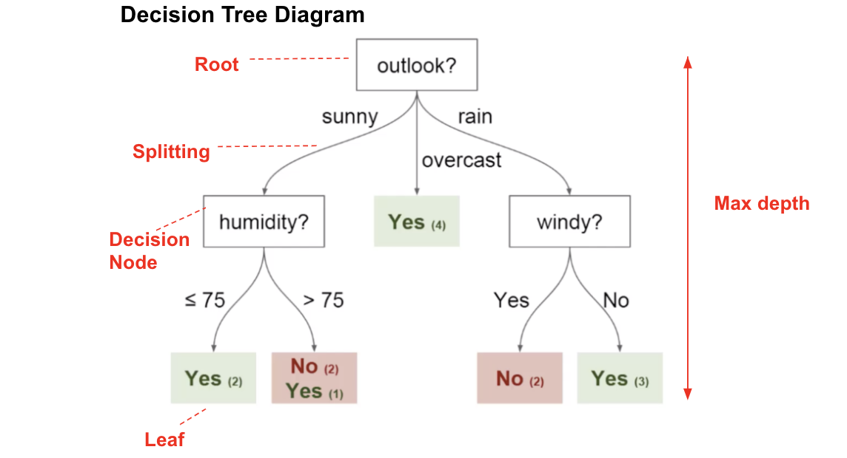

**Figure 2:** Training a binary decision tree using *(In this semester, one could be CART, ID3, C4.5… please choose)*. In this example, we show a model to predict whether or not to play Golf, according to weather.

**4.2.2 Testing algorithm**

Explain, briefly, how did you test the model: This is equivalent to explain how does your algorithm classifies new data after the tree is built.

**4.3** **Complexity analysis of the algorithms**

Explain in your own words the analysis for the worst case using O notation. How did you calculate such complexities.

|  |  |
| --- | --- |
| **Algorithm** | **Time Complexity** |
| Train the decision tree | O(N2*M2) |
| Test the decision tree | O(N3*M*2N) |

**Table 2:** Time Complexity of the training and testing algorithms. *(Please explain what do N and M mean in this problem.)*

|  |  |
| --- | --- |
| **Algorithm** | **Memory Complexity** |
| Train the decision tree | O(N*M*2N ) |
| Test the decision tree | O(1) |

**Table 3:** Memory Complexity of the training and testing algorithms. *(Please explain what do N and M mean in this problem.)*

**4.4 Design criteria of the algorithm**

Explain why the algorithm was designed that way. Use objective criteria. Objective criteria are based on efficiency, which is measured in terms of time and memory consumption. Examples of non-objective criteria are: “I was sick”, “it was the first data structure that I found on the Internet”, “I did it on the last day before deadline”, etc. Remember: This is 40% of the project grading.

**5. RESULTS**

**5.1 Model evaluation**

In this section, we present some metrics to evaluate the model. Accuracy is the ratio of number of correct predictions to the total number of input samples. Precision. is the ratio of successful students identified correctly by the model to successful students identified by the model. Finally, Recall is the ratio of successful students identified correctly by the model to successful students in the dataset.

**5.1.1 Evaluation on training datasets**

In what follows, we present the evaluation metrics for the training datasets in Table 3.

|  |  |  |  |
| --- | --- | --- | --- |
|  | ***Dataset 1*** | ***Dataset 2*** | ***...Dataset n*** |
| *Accuracy* | 0.7 | 0.75 | 0.9 |
| *Precision* | 0.7 | 0.75 | 0.9 |
| *Recall* | 0.7 | 0.75 | 0.9 |

## **Table 3.** Model evaluation on the training datasets.

**5.1.2 Evaluation on test datasets**

In what follows, we present the evaluation metrics for the test datasets in Table 4.

|  |  |  |  |
| --- | --- | --- | --- |
|  | ***Dataset 1*** | ***Dataset 2*** | ***...Dataset n*** |
| *Accuracy* | 0.5 | 0.55 | 0.7 |
| *Precision* | 0.5 | 0.55 | 0.7 |
| *Recall* | 0.5 | 0.55 | 0.8 |

## **Table 4.** Model evaluation on the test datasets.

**5.2 Execution times**

Compute execution time for each dataset in github. Measure execution time 100 times for each dataset and report average execution time for each dataset.

## 

|  |  |  |  |
| --- | --- | --- | --- |
|  | ***Dataset 1*** | ***Dataset 2*** | ***...Dataset n*** |
| *Training time* | 10.2 s | 20.4 s | 5.1 s |
| *Testing time* | 1.1 s | 1.3 s | 3.3 s |

## **Table 5:** Execution time of the *(Please write the name of the algorithm, C4.5, ID3)* algorithm for different datasets.

## **5.3 Memory consumption**

We present memory consumption of the binary decision tree, for different datasets, in Table 6.

|  |  |  |  |
| --- | --- | --- | --- |
|  | ***Dataset 1*** | ***Dataset 2*** | ***...Dataset n*** |
| Memory consumption | 10 MB | 20 MB | 5 MB |

## **Table 6:** Memory consumption of the binary decision tree for different datasets.

## To measure memory consumption, you should use a profiler. An very good one for Java is VisualVM, developed by Oracle, <http://docs.oracle.com/javase/7/docs/technotes/guides/visualvm/profiler.html> For Python, use C Profiler.

## **6. DISCUSSION OF THE RESULTS**

Explain the results obtained. Is precision, accuracy and sensibility appropriate for this problem? Is the model over-fitting? Is memory consumption and time consumption appropriate? *(In this semester, according to the results, can this be applied to give scholarships or to help students with low probability of success? For which one is better?)*

**6.1 Future work**

Answer, what would you like to improve in the future? How would you like to improve your algorithm and its implementation? What about using random forest?

# **ACKNOWLEDGEMENTS**

Identify the kind of acknowledgment you want to write: for a person or for an institution. Consider the following guidelines: 1. Name of teacher is not mentioned because he is an author. 2. You should not mention websites of authors of articles that you have not contacted. 3. You should mention students, teachers from other courses that helped you.

As an example: This research was supported/partially supported by [Name of Foundation, Grant maker, Donor].

We thank for assistance with [particular technique, methodology] to [Name Surname, position, institution name] for comments that greatly improved the manuscript.

# **REFERENCES**

1. Kalpesh Adhatrao, Aditya Gaykar, Amiraj Dhawan, Rohit Jha and Vipul Honrao. PREDICTING STUDENTS’ PERFORMANCE USING ID3 AND C4.5 CLASSIFICATION ALGORITHMS. Navi Mumbai, Maharashtra, India. September 2013. 14 pages.

2. Qasem A. Al-Radaideh, Emad M. Al-Shawakfa, and Mustafa I. Al-Najjar. Mining Student Data Using Decision Trees. Jordan. 2006. 5 pages.

3. M Krishna, Bandlamudi S B P Rani, G Kalyan Chakravarthi, B Madhavrao, S M B Chowdary. Predicting Student Performance using Classification and Regression Trees Algorithm. 2020. 8 pages.

4. Josip Mesarić, and Dario Šebalj. Decision trees for predicting the academic success of students. Osijek, Croatia. 2016. 22 pages.

1. <http://www.github.com/> ????????? /proyecto/